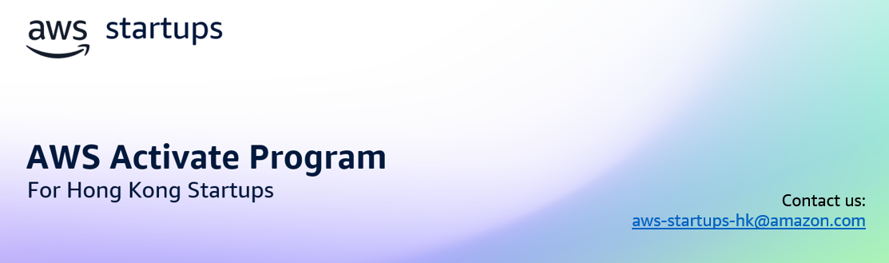
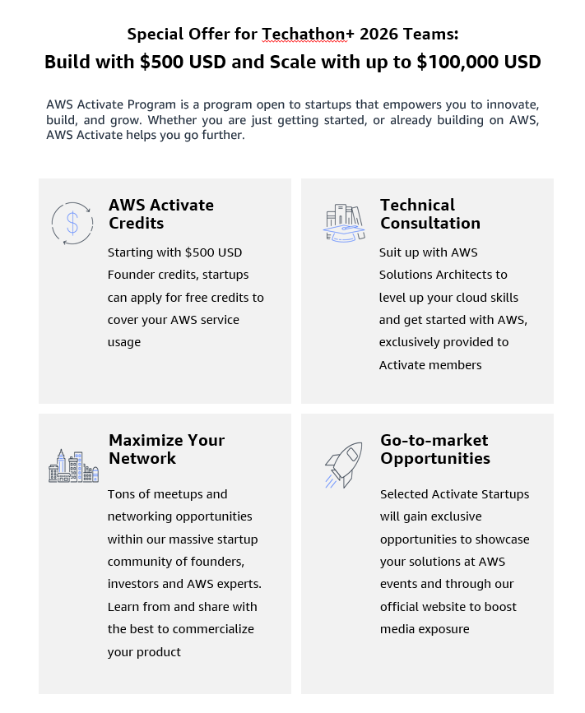

Get AWS credits by filling in this form! Please send this document to: aws-startups-hk@amazon.com

Note:
- You must have a valid Business Registration to apply.
- You must provide your AWS ID. If you haven’t got an AWS ID, sign up here.

- Company
Company name
Website
Accelerator/VC support  (please list out all) | HKSTP Techathon+ 2026

- Project
Project description
Project stage (select one) | [ ] Ideation  [ ] MVP  [ ] Early market  [ ] Growth
Development plan for the next 12 months (select one or more) | [ ] Launch a new product  [ ] Expand to new markets  [ ] Scale the business  [ ] R&D  [ ] Fundraising
Project team introduction

- Cloud Adoption
AWS workload (which AWS services you plan to use)
Current annual expenses on Cloud (pls include currency)
Current Cloud providers (if any)

- AWS ID
Please provide the AWS ID to which you wish the credits to be issued.
AWS ID (12-digit number)

- Please attach the following:
- Business Registration certificate
- Proof of accelerator/VC support (if applicable)

AWS Activate Program is subject to AWS Activate Terms and Conditions. AWS Activate credits are subject to AWS Promotional Credit Terms & Conditions. Startups previously received AWS Promotional Credit may not be eligible to receive additional credit. Each application will be reviewed individually and will be subject to the program's eligibility criteria.

